**Frontier Elementary School**

### 2024-2025

**Home of the Panthers**

**Gina Owens, Principal**

[owensg@pcsb.org](mailto:owensg@pcsb.org)

### Stephanie Stevens, Assistant Principal

### [stevensste@pcsb.org](mailto:stevensste@pcsb.org)

6995 Hopedale Lane Clearwater, FL 33764

Phone: 727-538-7335

website: [*http://www.pcsb.org/frontier-es*](http://www.pcsb.org/frontier-es)

**Office Hours – 8:00 AM – 3:30 PM**

**Student Hours M – F: 8:45 AM - 2:55 PM**

Students are welcomed to school at 8:15 each day. They may report to the PE Court to be supervised or to our cafeteria for breakfast. Breakfast is served from 8:15-8:40 each day. Students may enter the classrooms at 8:30. Our morning announcements are aired live on FTV and will begin promptly at the 8:40 bell. Classroom instruction will begin promptly at 8:45.

**YMCA Before and After School Care**

Call 727-467-9622 for information. Before school care begins at 6:30 a.m.

After school care is available until 6:00 p.m.

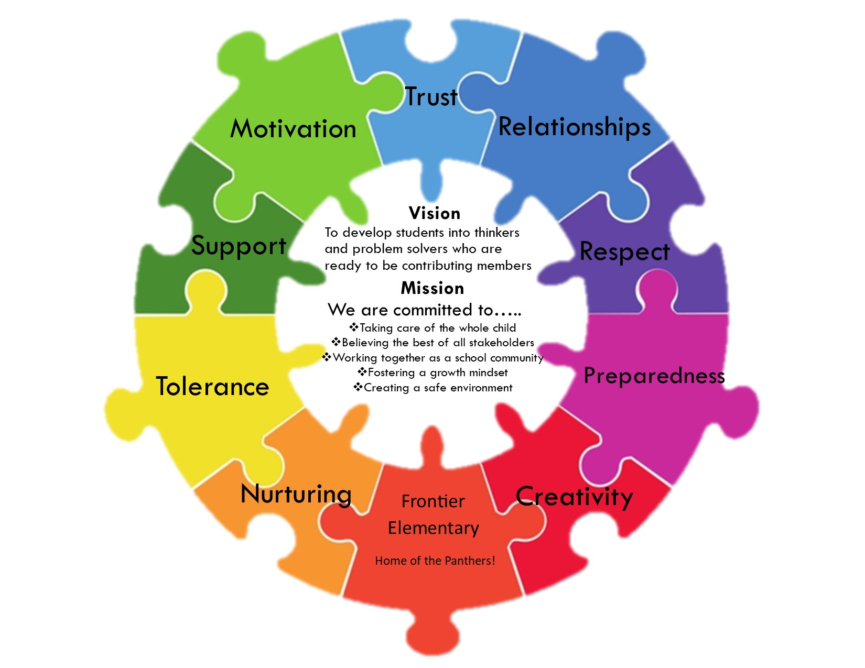

All stakeholders will work together to create a safe community that encourages students to become thinkers and problem solvers who are ready for higher education and success in a global society.

of society.

**Attendance/Tardies**

Students are expected to attend school daily as required by Florida state law. When it is necessary for your child to be absent, he/she must bring a note on the day he/she returns to school. The note, signed by a parent or guardian, should include the date(s) and reason for the absence or a parent may call the school at 727-538-7335 and leave a message with our front office. Parents may also access the attendance icon on our website to report an absence via e-mail. A poor attendance record often leads to poor academic progress. We certainly do not, however, want your child to come to school if he/she is sick. Chronic attendance problems will be referred to the school social worker and possibly the State’s Attorney’s office for investigation. If a child’s absence is due to extended illness, contact the school office for information regarding homebound instruction.

Parents must notify the school via one of the methods mentioned above if the child will be missing school due to a religious holiday. Requests for excused absences for family trips must be made at least three days in advance of travel. Forms are available in the front office.

It is important that all students arrive promptly to class. Chronic tardiness will be reported to the school social worker for investigation.

**Early Dismissal of a Student**

Parents are urged to give the school written notice in advance of doctor’s appointments, etc. Students must be signed out in the office. Early Dismissal ends at 2:30 p.m. Only the parent or adults listed by the parent may pick up a student. Identification will be required. Students will be called for dismissal when the parent or person listed checks into the office to check the student out.

**School Clinic**

If a student comes to the office because of illness, we will contact the parent or designee for pick up. **It is School Board policy that an emergency number be provided for this purpose.** Children sent home from school with a fever must be fever free for 24 hours without the use of fever reducing medication before they can return to school.

If it is necessary for a student to take any form of medication, prescription or nonprescription, (including cough medicine, cough drops, Tylenol, etc.) a Pinellas County Schools medication authorization form is required and must be signed by a parent. It is kept on file in the clinic. **Over the counter medication must be accompanied by a prescription from a physician or dentist.** Nonprescription medication must be presented in its original unopened container/packaging. All medicine must be brought into the school office by an adult.

Prescription medication must be presented to the school by a parent or guardian in the labeled, original container from the pharmacy. A child may not keep medication of any kind with him/her at school. If the parent forgets to give the morning dose before the child comes to school, we cannot administer the dosage. The parent must come to school to administer the medicine if he/she wants the child to make up a missed dose.

**Head Lice**

Head lice are often a problem in locations where groups of children play together. We take every precaution to prevent the spreading of lice, but we ask you to read this carefully to become more aware of “Fact versus Fiction” of this pesky nuisance. If your child is found to have lice/nits, you will be notified to pick up your child immediately. A parent or guardian must accompany the child to school for a recheck before the child to be readmitted to class.

**Facts you should know about head lice:**

A. Anyone can get head lice!

B. Lice prefer a clean hair shaft on which to lay and glue their eggs, or “nits”, so the nits do not get brushed off. The hair must be sectioned, and the eggs pulled off with fingertips or tweezers.

C. Lice are small insects that live in people’s hair and feed on their blood.

D. Head lice die quickly (within two days) without feeding so they cannot live very long away from your child’s head.

E. Lice are transmitted through close contact and/or sharing items like hats, scarves, brushes, pillows, etc.

F. If someone has lice, their scalp will be very itchy.

G. Treatments are available over the counter at any drug store. Read and follow all directions on the product you choose. If you cannot afford to purchase treatment, please communicate with our school nurse.

**Head Lice (cont.)**

H. All people in the household should be treated along with the laundry, bedding, towels, hair ornaments, hats, scarves, brushes, combs, etc. Non-washable items can be stored in sealed plastic bags for 10 days.

**I.** Students must be nit free to return to school and must be rechecked by school personnel in the front office before returning to class.

**Parent – Teacher Conferences**

Conferences may be arranged by phone or written communication. Each parent will be invited to confer with their child’s teacher at least once during the school year. We host a Meet and Greet prior to the beginning of school so students and families can meet the teacher and acclimate themselves with the campus. A Back to School Open House is held in August. The purpose of this event is to give parents an overview of the curriculum, behavioral expectations, materials and teaching techniques.

**Visitors**

School board policy requires that all visitors report to the office. All visitors need to present identification such as a driver’s license or state identification card. Visitors are required to wear a visitor badge and must be accompanied by school personnel unless the visitor has Level 2 clearance. To obtain Level 2 clearance, please contact our Volunteer Coordinator for details. Visitors requesting to observe the teaching process or their child in the classroom, must contact an administrator at least 48 hours in advance. Anyone wishing to have lunch with a student must be listed on the student’s information card. Children will be signed out and can have lunch at the picnic tables in front of the school.

**Volunteers**

Volunteers are welcomed and appreciated at Frontier. As a volunteer, you can serve in many ways. The possibilities and needs are endless. If you have a little time and would be willing to get involved at our school, please contact our Family Community Liaison. You do not have to obtain Level 2 clearance to be a volunteer, but Level 2 clearance will allow you to work without direct supervision of school personnel. You must be a registered volunteer with Level 2 clearance to chaperone field trips. Volunteers may not bring preschoolers or children not registered in the school along when volunteering. All paperwork needed to become a volunteer is available at [www.pcsb.org/volunteer](http://www.pcsb.org/volunteer) and will be submitted electronically.

Please consider becoming involved. The benefits are worth it!

**Bicycles**

All bicycles will be parked in the bike compound. Locks are strongly recommended for all bikes. The school cannot be responsible for damaged or stolen bicycles. **All students riding bikes to school are required by law to wear helmets.**

**Bus Transportation**

The bus driver has the responsibility for the safety and conduct of the students riding the bus to and from school. Students should obey the bus driver **at all times**. Any student who persists in disorderly conduct on a school bus will be reported to the school administrator and may be suspended from the bus. Students should know the arrival time of the bus and be ready and waiting when the bus arrives. Students should arrive at the bus stop 10 minutes before the actual pick up time. Drivers will make every attempt to be on time. **Parents are responsible for the supervision of their children at the bus stop prior to the arrival of the bus.** Transportation is provided for all registered students living two or more miles from school.

**If your child rides a bus to school each day, you can keep updated on any issues by signing up for Bus Bulletin.** Bus Bulletin will notify you by text, phone call or email if: a bus is late, a route has changed, or there has been an accident. If your child rides a bus, please take advantage of this free service. Sign-up by going to <http://busbulletin.com/parents/>. The bus bulletin link can also be found on the district website. Just click on the Transportation button.

If you have questions concerning transportation, please call the Transportation Help Desk at 587-2020.

**Safety**

The safety of our students and staff is a top priority. Frontier has security cameras that monitor our campus 24 hours a day. Our campus is designed for the security and well-being of all staff and students. Fire and Active Threat drills are held monthly. We invite parents and community members to share their concerns and/or suggestions by contacting the front office.

To ensure the safety of our students who walk to school, we ask that children cross with the crossing guard (where one is available) and go directly to and from school each day. Students who walk home should not loiter by the bridge or retention pond. These areas are not part of the school property and are not supervised by school personnel. If you have any safety concerns, please contact our principal, Gina Owens, at 727-538-7335 or e-mail [owensg@pcsb.org.](mailto:owensg@pcsb.org.)

**Smoking**

In compliance with Pinellas County School Board Policy, there will be no smoking of any kind on school grounds. This includes e-cigarettes and vaping. This also applies to individuals who are inside cars on school board property.

**Toys, Candy and Gum**

Please make sure that your child does not bring these items to school. Remember that children can be suspended for bringing toy weapons to school. If your child does bring any of these items, they will be confiscated by an administrator or classroom teacher.

**Family Involvement Activities**

Throughout the school year family events are held. Topics are determined based on needs expressed by parents through surveys and student achievement data. We believe active parent engagement improves students’ academic success, and we strive to implement parent events that link to learning.

**PTA**

The mission of PTA is to make every child’s potential a reality by engaging and empowering families and communities to advocate for all children. We encourage all families to join and be active in our PTA. Please call the school office to leave a message for our PTA President.

**School Advisory Committee (SAC)**

Each school in the State of Florida must have a SAC.  By law, each SAC must be composed of the principal and an “appropriately balanced” number of “stakeholders.” These individuals must be representative of the ethnic, racial and economic makeup of the community served by the school. The role of the School Advisory Committee is to plan for and promote high student achievement in the school.

Each year the SACs in Title I schools review and offer input into their individual school improvement plans, school parent involvement policies, parent-student-school compacts for learning, and the use of funds to support high student achievement. Our SAC meets monthly. If you would like to become a SAC member of Frontier Elementary, please contact us at 727-538-7335.

**PCS Focus**

PCS Focus is a secure website used to maintain student records and to communicate with parents. If you are a new user, a log in can be provided by your child’s school.

If you are a previous Parent Connect user and have forgotten your username, please ask at the front office.

What can parents/guardians do in Focus?

1. View attendance and be alerted to concerns about your child’s attendance.
2. View in-progress grades, test/quiz scores, homework grades and project work.
3. View discipline/referrals.
4. View important school messages, announcements and upcoming school events.
5. Contact your child’s teacher via direct e-mail links.

**STUDENT PASSWORD INFORMATION**

Write down your User Name and Password on the following lines. Make **Clever.com** a favorite.

The children’s User Name and Password are used to log onto a computer at school, log onto Focus and Clever. From Clever.com they can access programs such as I-Station, Myon, Dream Box, I-Ready, Canvas, Code.org, Khan Academy, Office 365, BrainPOP, Nearpod and E-Books on programs like MackinVIA, Sora and Destiny.

USER NAME______________________________

PASSWORD______________________________

Additional websites we use can be found on our Frontier Home page: [**http://www.pcsb.org/frontier-es**](http://www.pcsb.org/frontier-es)

Located on the students’ page under Resources.

**…………………………………….......................................................................**

**Welcome to Title I at Frontier Elementary School**

Title I is a federally funded program designed to address the academic needs of students and to assist them in meeting the state’s high standards, particularly in the areas of reading, writing, math and science. The Pinellas County School District receives funds based upon the number of students who are eligible for free or reduced-price lunch.

**What is a Title I School?**

Title I schools are determined by the percentage of students at each school who are eligible for free or reduced lunch. You may see the following at Frontier because we are a Title I school:

* +  Intervention teachers – provide intensive assistance in reading and math
  +  Additional resource teachers and assistants who are highly qualified
  +  Additional training for school staff
  +  A variety of teaching methods and materials
  +  Special learning events
  +  Trainings for Families
  +  Before and After school tutoring

*****The Frontier Parent Family Engagement Plan and the District Parent Family Engagement Plan are available for viewing in the front office. Stop by and ask to take a look.

**Frontier Elementary Guidelines For Success**

**-Be Responsible - Be Tolerant**

**- Be Safe -Be Respectful**

**- Be an Active Learner**

**Restorative Practices and PBIS**

Through the integration of Restorative Practices and our Positive Behavior Interventions and Supports system (PBIS) we are promoting and strengthening our school culture and enhancing the social emotional skills of our students within the school community.

The aim of restorative practices is to **develop community and to manage conflict and tensions by repairing harm and building relationships.**